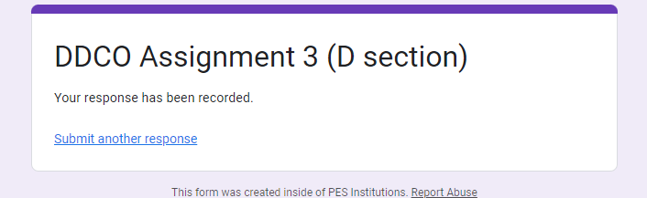

DDCO ASSIGNMENT 3

31-08-23

GAUTAM V HANCHINAL

PES1UG22CS215

SECTION D

1. FULL ADDER:

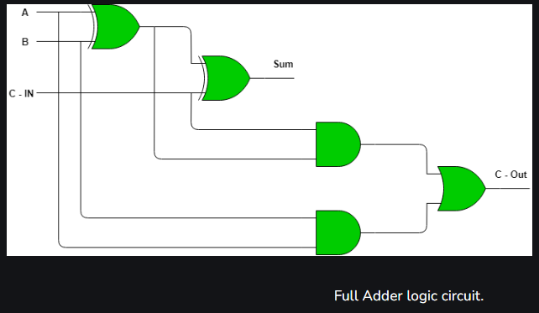

SOURCE : GEEKforGEEKS

Main Code:

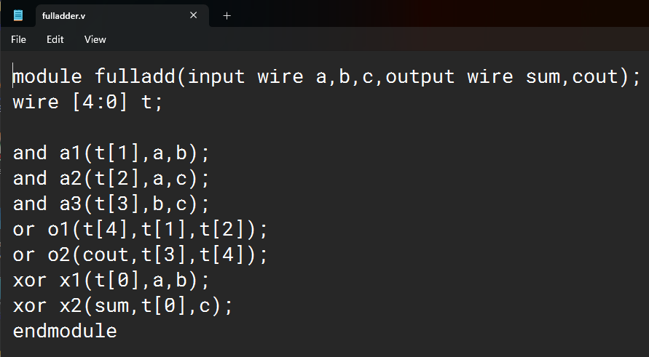

Test Bench:

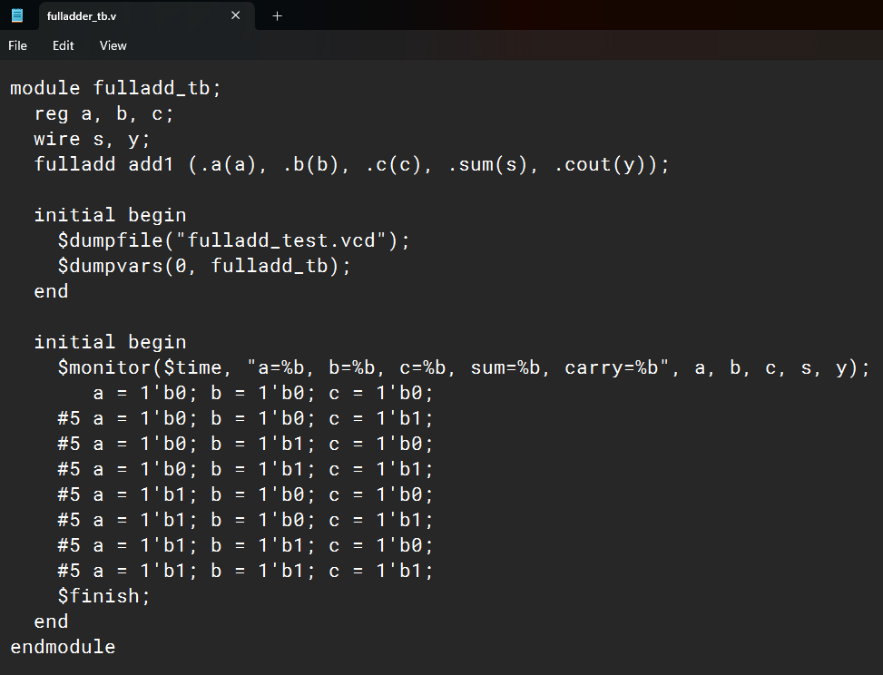

VVP Output:

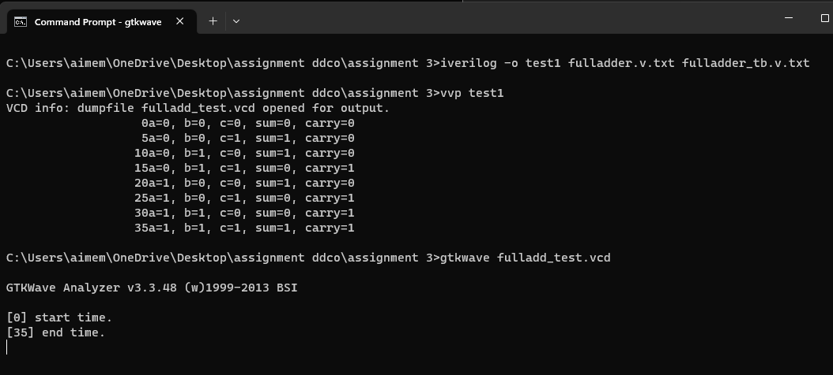

GTKWAVE output:

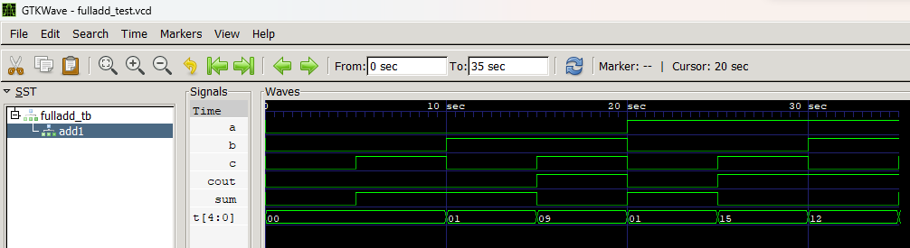

Truth Table:

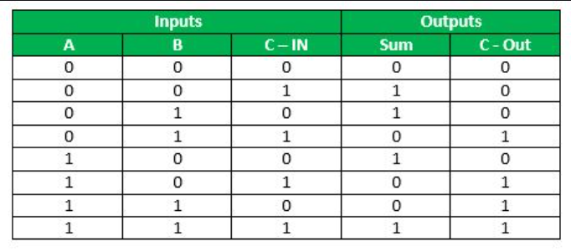

SOURCE : GEEKforGEEKS

1. 2:1 MUX

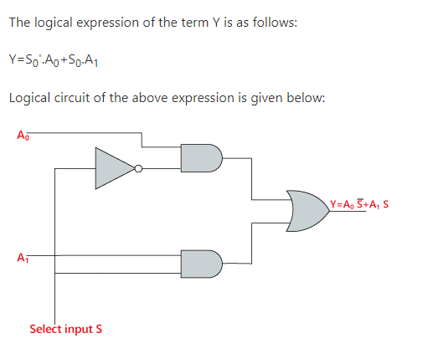

SOURCE: javatpoint.com/ multiplexer-digital-electronics

Main Code:

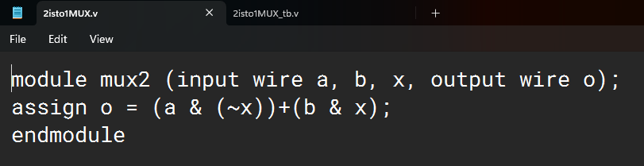

Test Bench:

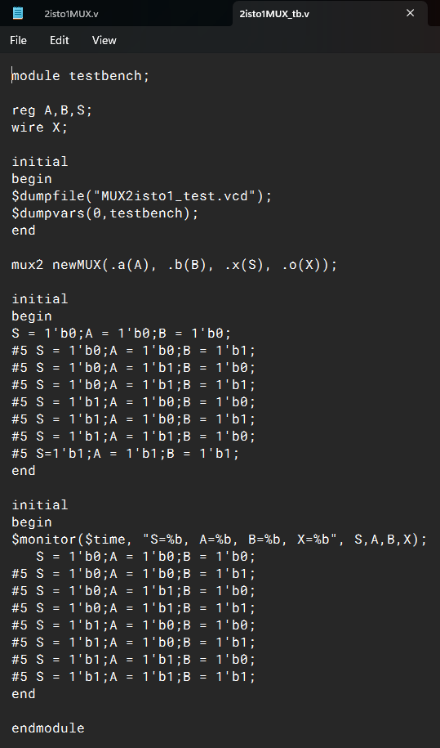

VVP output:

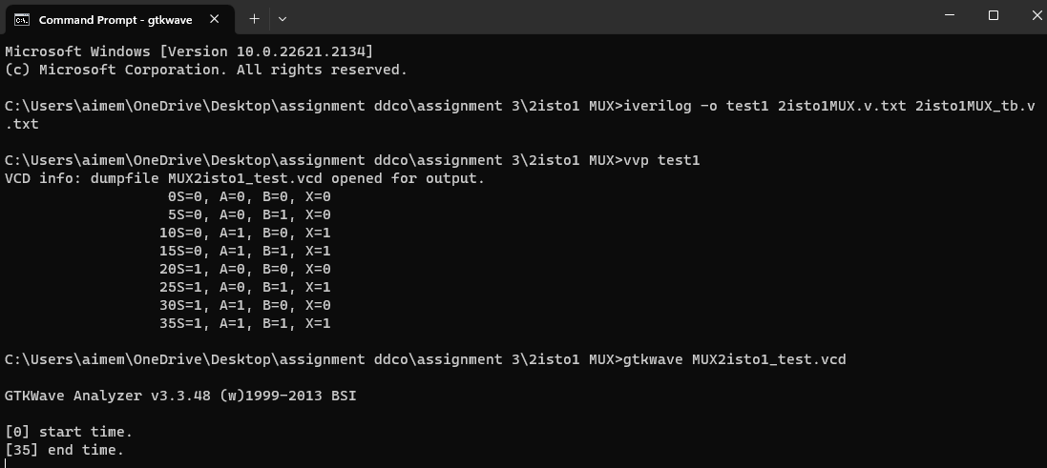

GTKWAVE output:

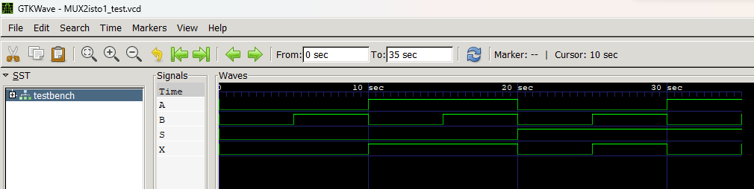

Truth Table:

|  |  |
| --- | --- |
| ***INPUT(s)*** | ***OUTPUT*** |
| ***So*** | ***X*** |
| 0 | A |
| 1 | B |